GPS Tracker
User Manual
For Auto, scooter and motorcycle

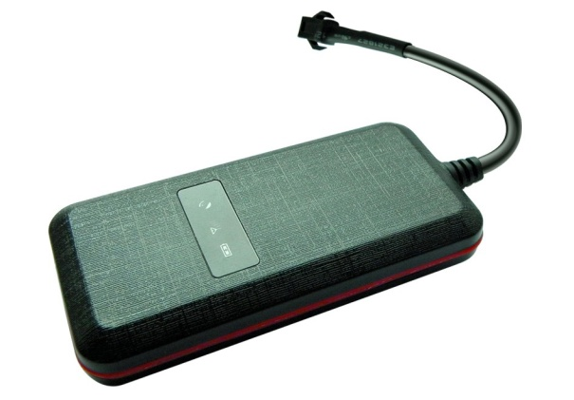
Please read the manual carefully before use the GPS Tracker so that you can install the device correctly and activate it quickly on the internet. The outlook and true color are subject to the actual product.

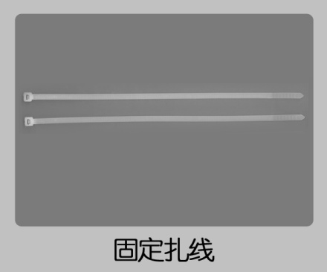
1．Accessories：
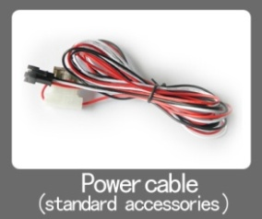
2. Technical parameter
1）.GSM：850/900/1800/1900 Quad band
2）.GPRS: Class12, TCP/IP
3）.Working Voltage：9-24V DC
4）.Working current：≈22mA (12vDC)
5）.Working current：≈12mA (24vDC)
6）.GPS locating time：Cold start≈38s（Open sky）
Warm start≈32s
Hot start≈2s（Open sky）
7）.GPS Precision：10m（2D RM）
8）.Working temperature：-20℃～+70℃
9）.Working humidity：20%～80%RH
10）.Measurement：87（L）×43（W）×14（H）mm
3.Out look
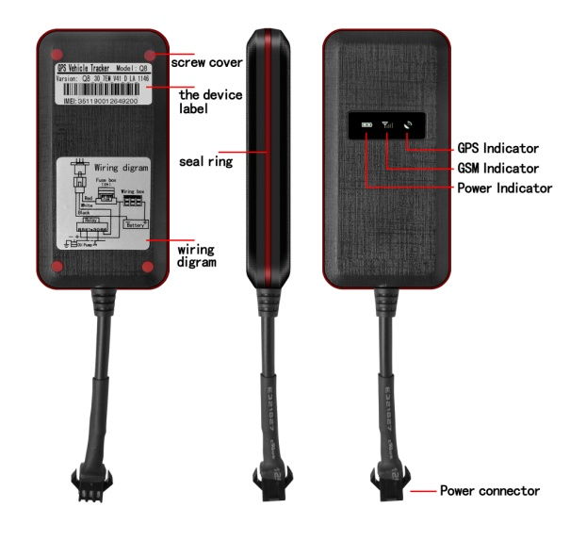
4.Device status indicators
4.1Connect DC 9-24V power supply and the red LED will light continuously.
4.2The green LED glistens when searching the GPS signals. When GPS works, the LED lights continuously.
4.3The intermediate blue LED (GSM signal state)
GSM signal is normal, blue LED light long bright. No GSM signal, the blue LED flashes.
GPS LED not fixed, flashes（0.2 sec/2 sec），Positioning long bright；
GSM LED no signal, flashes（0.2 sec/2 sec），Signal normal long bright；
Power LED: long bright;

All LEDS will turn off after 5 minutes. When there is a new call, the LEDs will relight and turn off 5 minutes later.

5.Installation
5.1 Preparation for the installation
5.1.1 Product Check. Open the packing box and check the device‘s model and accessories. If the model is wrong or the accessories not complete, please contact the dealer.
5.1.2 Choose SIM card. Please insert a SIM card to the device. Please take dealer’s advice as reference.
5.1.3 SIM card installation. Discharge the cover of the device and uncover the SIM card holder. Then insert the SIM card and cover SIM card holder (as follows).
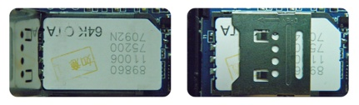

5.1.4 Put back the front cover and screw it up.
5.1.5 Connect the device to the 9-24Vpower supply.（the red LED constant glow）
5.1.6 Install the device in the hidden place of the car；

The SIM card must be with GPRS function and enough deposit. If your SIM card need input PIN when power on, please cancel it.

5.2 Installation
The GPS tracker must be installed under professional personnel.
Note：
1) Please install the device in the hidden place as followings：
Under Front windshield；
In the front instrument panel；
Under back windshield；
2) Avoid being placed with signal radiators like reverse sensor ；
3) The device has GSM antenna and GPS antenna inside. Please ensure the receiving side of the device is face up and without metal cover.

Note：The metal cover will lessen the receiving of GPS signals.6. The device connecting requirements.
6. Device wiring requirements
6.1 The device power supply is DC 9-24V. The red line is positive pole while the black line is negative pole.
6.2 The negative pole of power supply connects with ground or the metals. Please do not connect with other ground lines.
6.3 When finishing the power supply wire connection, please make the plug of power supply to the device.
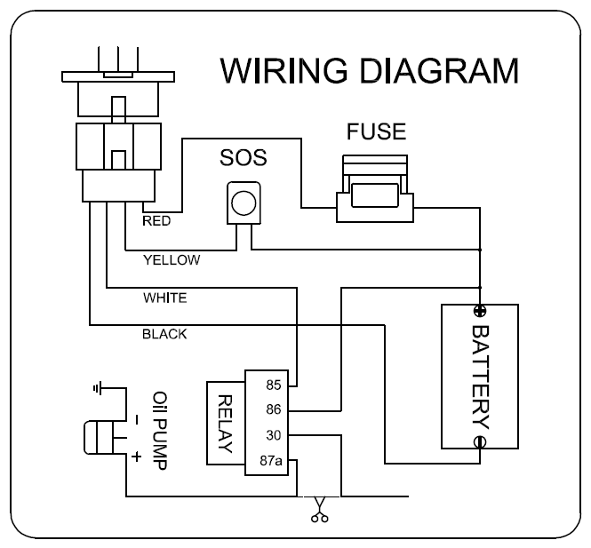
7.The Device Working
7.1 Power on: the device will be power on when connecting to the current. Then the three LED indicators will light continuously. The device will upload the data to the online platform (the default interval of uploading data is 10seconds). When the car is in static state for a long time, the device will be in energy saving mode and it will be more smart and precise.
7.2Power off：Pull off the power plug then power off the device.

8.User Settings
8.1 Set class instruction
Note:
1: the equipment the default password is 123456
2: when close monitor function ,use center number call the device ,it will reply google map link
1)CENTER
Text command | Parameter | Sample
CENTER Add | #admin#password#number1#number2#number3 | #admin#123456#13713720011#13813800001#13555588801
CENTER Del | #deladmin#password#number1# | #deladmin#123456#13713720011#
Command Description | 1)Center number can control the oil and power and resume factory settings  2) Center number can receive the call and text of vibration alarm and over speeding alarm.  3) SIM must display the income call number to control oil and power.  4) Change center number must resend the command
Command Feedback | Successful Setting：admin ok  delalladmin ok

2)APN
Text command | Parameter | Sample
APN Setting | 1.  #apn#123456#APNname#  2. #apn#123456#APNname#usename#password | 1.#apn#123456#cmnet#  2.#apn#123456#cmnet#cmnet01#666666#
Command Description | APN differs according to the local telecom operators.  For example：APN request password，please refer to Sample2，and Sample1 for no password.
Command Feedback | set apn：******** ok”

3)IP/PORT
Text command | Parameter | Sample
IP Setting | 1.#ip#123456#ip#port  2.#ip#123456#DNS#port# | #ip#123456#58.61.154.247#7018#  #ip#123456#www.18gps.net
Command Description | If set ip please refer sameple1  If set DNS, please refer sameple2
Command Feedback | set ip：******** ok

4)GMT
Text command | Parameter | Sample
GMT | #timezone#123456#location’time# | #timezone#123456#E8#
Command Description | The default time zone is Beijing time. If time zone need revised, please operate according to the above command.
Command Feedback | Successful Setting：Set time zone ok!

5)TIME
Text command | Parameter | Sample
TIMEER Parameter setting | #uptime#uploading interval# | #uptime#20#
Command Description | Time scope：0，10~60 seconds； 0,no data uploading；  10~60,means time interval；the default value is 15 seconds！
Command Feedback | Successful Setting：SET TIMER OK！

6)VIBRATION
Text command | Parameter | Sample
VIBRATION Parameter | #vibrate#123456#5#2# | 5 is value of the vibration  2 is alarm way
close vibration alarm | #novibrate#123456# | Close vibration
Command Description | the sensitivity value of the vibration is from 1 to10 ，1 is the most sensitive Alarming ways: 1,platform 2,platform and texting, 3 platform and calling.  Must set the center number and receiving number.
Command Feedback | set vibration alarm level，OK!

7)SPEEDING
Text command | Parameter | Sample
SPEEDING Parameter | #speed#123456#080# | More than speed-80 km/h alarm
Close speeding alarm | #nospeed#123456# | Close speeding alarm
Command Description | The speed scope is form 60-220, if the speed is no this scope, the alarm is off.  Must set the center number and receiving number.
Command Feedback | Successful Setting：  set speed-80 km/h ok  set nospeed ok

8)RELAY
Text command | Parameter | Sample
RELAYParameter1 | #stopoil#123456# | cut off oil and power
RELAYParameter2 | #supplyoil#123456# | recover oil and power
Command Description | 1)RELAY control the start and closeness of the relay  2) Only the center number can operate.  3）the device only cut off the oil circuit on the condition of the driving speed below 20KM/H or in static state.  4)When send the command, the device will reply “please waiting “When the vehicle speed is over 20KM/H, the device will cut off the oil or the power when the speed below 20KM/H.
Command Feedback | Successful Setting：  stop oil ok  supply oil ok

9)WHERE
Text command | Parameter | Sample
WHERE | #position# | Get adress
WHERE | #123# | Get adress
Command Description | Check information of the device
Command Feedback | IMEI:35455565000000000Speed:0km/h Address:********** 11:58

10)monitor（Option）
Text command | Parameter | Sample
monitor | #monitor#123456# | Open monitor
monitor | #nomonitor#123456# | Close monitor
Command Description | Only center number is available
Command Feedback | open monitor ok  close monitor ok

10) cut off power alarm
Text command | Parameter | Sample
Cut off power | #power2# | Cut off power alarm for SMS and platform
cut off power | #power3# | Cut off power alarm for calling and platform
Close | #power0# | Close alarm
Note | Default power2
Command Feedback | open power warning-2 ok  open power warning3 ok  close power warning ok

11)sos（Option）
Text command | Parameter | Sample
Sos1 | #sos2# | Sms alarm and platform
Sos2(default) | #sos3# | Calling alarm and platform
Close sos | #sos0#
Command Feedback | Successful Setting：  open sos warning-2 ok  open sos warning-3 ok  close sos warning ok

12)PARAM
Text command | Parameter | Sample
PARAM | #param#123456#
Command Description | The command is to check the settings and the default parameter.
Command Feedback | IMEI:351190012535936  APN : cmnet  IP:IP and port  TIMER: moving uploading interval  LANG: language(CN/EN)  GMT: time zone (E/W8)

13)STATUS
Text command | Parameter | Sample
STATUS | #status#123456#
Command Description | The command is designed for checking the device’s working status.
Command Feedback | External power:ON/OFF  GSM Signal:HIGH/MIDDLE/LOW  GPS:FIXED/UNFIXED  RELAYER:DISABLE/ENABLE  LISTENING:OFF  Outside battery

14)REBOOT
Text command | Parameter | Sample
Reboot | #reboot#123456#
Command Description | The command is to remote reboote device
Command Feedback | Reboot ok

9.Trouble shooting
9.1The device is not online or offline on the web platform
9.1.1First, please check the three LED working state. Ifpossible. You can call the device’s number to check.
● If not connected, the device is out of signal. If the GSM signals cannot reach your location, pleasedrive to the open sky.

- If reminding the device SIM card is out of deposit, please make deposit by the telecom operator.

● If you can connect to the device when calling, the SIM card has deposited and please check with your operator for GPRS function. You also can check by searching the internet on your mobile phone.

● If reminding the device is power off, please turn back the device and proceed as followings:
a)Check if the red LED is in constant glow. If the LED is dark, please check the power connecting. If fuse is broken, please return the device to the seller.
b)If the blue GSM LED is not in constant glow, please check the installation of SIM card.
9.1.2 Please check the offline area in order to judge if the network problem of operators.
9.2 When GPS cannot receive the signals, please drive in the open sky and ensure there is no metal thins on the device.
9.3 When the device cannot receive the GSM signal, please check the SIM card installation. If the GSM signals cannot reach your location (such as the basement), please drive to the open sky.
9.4 The red LED is not glow when power on. Check the fuse of the power line. If the fuse is fused, please change the fuse with the seller.

